- [10] git-tutorial.tar.gz pushed to repo contents are evaluated b y later criterion
  - Just check that the one file is pushed
- [10] “Initializing a Repository in an Existing Directory" Exercises HelloWorld repo

- [10] "Cloning an Existing Repository" Exercises libgit2 repo
  - Just check repos are in directory:
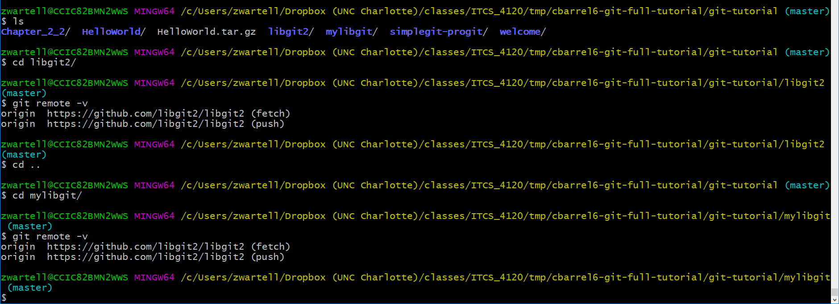
- [50] ProGit_Chapter_2_2 Exercises
  - Check for presence of original files
  - Check for git add/commit of Contributions.md and README
  - Check for git delete of PROJECTS.md
    - May or may have commit this delete. That is ok.
  - 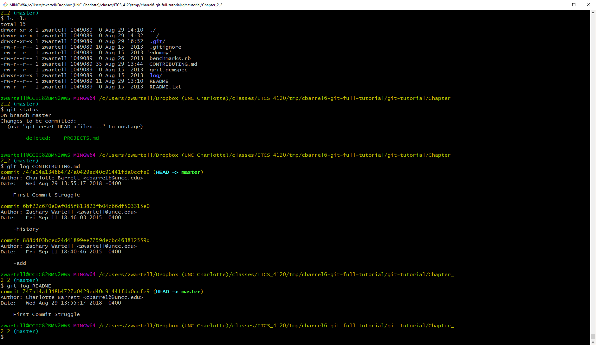
- [20] simplegit-progit Exercises
  - Just check for presence of simple-git-progit
